**San Francisco Bay University**

**CS483L - Artificial Intelligence & Machine Learning Lab**

**2022 Summer Final Exam**

**Student Name: Student ID:**

**Instruction**

1. **Put your answer right after each question in the answer sheet**
2. **Make a copy & paste of your program in text mode, NOT image except running results onto the answer sheet.**

**Part I Complete the following questions in python programs by the functions in Scikit Learn**

1. Normalize matrix x by scikit learn function(s)

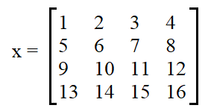

1. Binarize matrix x by scikit learn function(s) with threshold value = 5.5

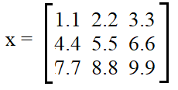

1. Given the following dataset, find coefficients in 1st order linear hypothesis function

*X = [[6], [8], [10], [14], [18]]*

*y = [[7], [9], [13], [17.5], [18]]*

*X_test = [[8], [9], [11], [16], [12]]*

*y_test = [[11], [8.5], [15], [18], [11]]*

1. Assuming that we have a dataset with 2 features x0 and x1 as follows, separate them by K-means algorithm. Notice that you make a decision about K’s value

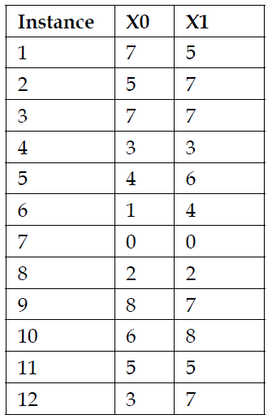

**Part II Create user-defined python functions**

1. Implement matrix multiplication x*y. E.g.

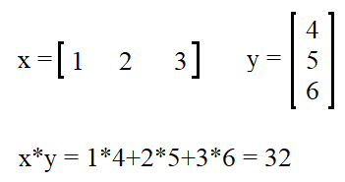

1. Transpose matrix x. E.g.

